**Higher Nationals - Summative Assignment Feedback Form**

|  |  |  |  |
| --- | --- | --- | --- |
| **Student Name/ID** | Nguyen Van Hieu_GCH211369 | | |
| **Unit Title** | Unit 13: Computing Research Project | | |
| **Assignment Number** | 1 | **Assessor** | Nguyen The Lam Tung |
| **Submission Date** |  | **Date Received 1st submission** |  |
| **Re-submission Date** |  | **Date Received 2nd submission** |  |
| **Assessor Feedback:**  *Please note that constructive and useful feedback should allow students to understand:   1. Strengths of performance 2. Limitations of performance 3. Any improvements needed in future assessments   Feedback should be against the learning outcomes and assessment criteria to help students understand how these inform the process of judging the overall grade.  Feedback should give full guidance to the students on how they have met the learning outcomes and assessment criteria. | | | |
| **Grade:** | **Assessor Signature:** | | **Date:** |
| **Resubmission Feedback:**  *Please note resubmission feedback is focussed only on the resubmitted work | | | |
| **Grade:** | **Assessor Signature:** | | **Date:** |
| **Internal Verifier’s Comments:** | | | |
| **Signature & Date: Hieu** | | | |

* Please note that grade decisions are provisional. They are only confirmed once internal and external moderation has taken place and grades decisions have been agreed at the assessment.

# TABLE OF CONTENT:

TABLE OF CONTENT: 2

TABLE OF FIGURE: 3

1. Introduction the purpose of the research 4

2. Literature review 6

P2: clearly discuss previous methodologies with examples, academic references 12

M1: justifications for the choice of methods selected based on philosophical/theoretical frameworks which can be seen in [section 2 and 3] 12

3. Primary research 12

P3: clearly provide evidence of carryout primary research in [section 3] and in [section 2] 22

M2: Discuss merits, limitations and pitfalls of approaches to data collection and analysis 22

D1: Critically evaluate research methodologies and processes and use it effectively which can be seen in secondary research and primary research 22

4. Analyse the result of the primary research 22

P4: Effective using analytical tools to analyse research findings and data 22

P5: the hypothesis in the literature part with appropriate justification 31

M3: Effectively suggest the research’s results to some audience(how it is useful for them) 33

D2: Excellent research with useful findings and recommendations 33

5. Approved project proposal-appendix 33

6. Approved project plan-appendix 33

7. Ethical form 33

8. Other materials which collected while conducting primary research: interview scripts, audio, experiment notes-appendix 33

Bibliography 33

# TABLE OF FIGURE:

Figure 1: excel 23

Figure 2: tableau 23

Figure 3: google forms 24

Figure 4: question 1 25

Figure 5: question 2 25

Figure 6: question 3 26

Figure 7: question 4 26

Figure 8: question 5 27

Figure 9: question 6 28

Figure 10: question 7 29

Figure 11:question 9 29

Figure 12: question 9 30

Figure 13: question 10 31

# 1. Introduction the purpose of the research

The purpose of our research project is to leverage advanced machine learning techniques to enhance the speed and accuracy of weather forecasting. In an era marked by increasing climate variability and the growing impact of extreme weather events, there is a pressing need to improve our ability to predict weather patterns with greater precision and timeliness. By harnessing the power of machine learning algorithms, we aim to develop more efficient and reliable forecasting models that can provide actionable insights to individuals, businesses, and policymakers.

**The main aims and objectives of our project include:**

Investigating the potential of machine learning algorithms in improving weather forecasting accuracy: We will explore various machine learning techniques, including supervised learning, unsupervised learning, and deep learning, to identify the most effective approaches for enhancing forecast accuracy.

Enhancing the speed of weather forecasting models: In addition to accuracy, speed is crucial for delivering timely forecasts that enable proactive decision-making. We will develop methodologies to streamline the forecasting process and reduce computational time without sacrificing accuracy.

Integrating real-time data sources for dynamic forecasting: Weather conditions are constantly evolving, necessitating the integration of real-time data sources such as satellite imagery, weather station observations, and numerical weather prediction outputs. We will investigate techniques for efficiently assimilating these diverse data streams into our forecasting models.

Evaluating the performance and reliability of machine learning-based forecasting models: Rigorous evaluation is essential to assess the effectiveness and robustness of our forecasting models. We will employ comprehensive validation metrics and comparative analyses to benchmark our models against existing forecasting methods.

Addressing ethical considerations and ensuring responsible use of forecasting technology: Ethical considerations, such as data privacy, informed consent, and transparency, will be carefully addressed throughout the research process. We are committed to upholding ethical standards and safeguarding the rights and well-being of participants and stakeholders.

**What the research will do:**

Develop machine learning models capable of improving the accuracy and speed of weather forecasting.

Integrate real-time data sources to enhance the dynamic nature of forecasting models.

Evaluate the performance of machine learning-based forecasting models through rigorous validation and comparison with existing methods.

Uphold ethical standards and ensure responsible conduct throughout the research process.

**What the research won't do:**

The research won't aim to replace traditional meteorological methods entirely but rather complement them with advanced machine learning techniques.

It won't overlook the ethical considerations and implications associated with handling weather data and engaging with participants.

It won't guarantee absolute accuracy or eliminate uncertainties inherent in weather forecasting, but it will strive to improve prediction capabilities to the best of our abilities.

**Appropriate research question:**

Can machine learning algorithms enhance the speed of weather forecasting without compromising accuracy?

How can real-time data integration be optimized to provide timely and reliable weather predictions?

What are the most effective techniques for processing and analyzing large volumes of weather data for rapid forecasting?

How can we leverage historical weather data to improve the predictive capabilities of machine learning models?

What measures can be implemented to ensure the scalability and efficiency of weather forecasting systems in handling increasing data volumes?

How do different machine learning models compare in terms of speed and accuracy for weather forecasting applications?

**Related documents in the research proposal:**

Machine Learning Techniques for Meteorological Forecasting" by Richard J. McAllister and Glenn M. Hymel: This comprehensive book explores various machine learning techniques applied to meteorological forecasting, offering insights into algorithm selection, model evaluation, and real-world applications.

"Advances in Weather Forecasting Models and Techniques" edited by Fiona M. Mullin and Adam J. Smith: This edited volume covers recent advancements in weather forecasting models and techniques, including contributions from experts in the field on topics such as ensemble forecasting, data assimilation, and high-resolution modeling.

"Deep Learning for Weather Forecasting: A Review" by Yarin Gal and Konstantinos G. Nikolaidis: This review article provides a comprehensive overview of deep learning approaches for weather forecasting, discussing neural network architectures, data representation, and performance evaluation metrics.

"Statistical Methods in the Atmospheric Sciences" by Daniel S. Wilks: This classic text offers a solid foundation in statistical methods commonly used in atmospheric science research, including time series analysis, spatial statistics, and probabilistic forecasting

# 2. Literature review

Welcome to my innovative project aimed at revolutionizing livestock farming, particularly focusing on dairy cows. As I delve into the intricacies of this domain, I have identified three key hypotheses that will guide our research and development endeavors.

My first hypothesis revolves around conducting thorough research to determine the best and most optimal methods to apply to livestock farming projects, with a special emphasis on dairy cows. Livestock farming, particularly dairy farming, is a complex endeavor that requires a nuanced understanding of various factors such as animal health, nutrition, breeding practices, and environmental conditions. By meticulously researching and analyzing existing methods and practices, I aim to identify innovative strategies that can enhance the efficiency, productivity, and sustainability of dairy farming operations.

My second hypothesis centers on collaborating with interface experts to design a common interface tailored specifically for the needs of livestock farming projects. An intuitive and user-friendly interface is essential for facilitating seamless communication, data management, and decision-making within the farming community. By engaging with interface experts and leveraging their expertise, I seek to develop a unified interface that streamlines interactions between farmers, veterinarians, suppliers, and other stakeholders involved in livestock farming. This common interface will enhance efficiency, promote knowledge sharing, and foster collaboration across the agricultural sector.

Lastly, my third hypothesis focuses on the analysis of data obtained from customers, farm owners, and livestock experts. Data-driven insights are invaluable for informing decision-making, identifying trends, and uncovering opportunities for improvement within the livestock farming industry. By gathering and analyzing data from diverse sources, including customer feedback, farm management systems, and expert recommendations, I aim to gain a comprehensive understanding of the challenges and opportunities facing the industry. This data-driven approach will enable me to tailor our solutions to meet the evolving needs of farmers, improve animal welfare, and drive sustainable agricultural practices.

My project is driven by these three hypotheses, each representing a distinct aspect of our research and development efforts. By combining rigorous research, collaboration with experts, and data-driven analysis, I aspire to create innovative solutions that empower farmers, enhance livestock welfare, and promote sustainability in the dairy farming industry.

**The initial hypothetical proposals are included in my project:**

Hypothesis 1: Research and understand the obtained data to choose the most optimal algorithm for the project.

Hypothesis 2: Through observational research, I can analyze weather patterns and phenomena over an extended period to identify correlations, trends, and anomalies, thereby enhancing my understanding of local climate dynamics and improving the accuracy of weather forecasting models.

Hypothesis 3: Research and interview experts to come up with the most optimal interface design for the application.

Hypothesis 4: Research and analyze feedback from customers and experts in the field, thereby further developing the project.

1. **Hypothesis 1: Research and understand the obtained data to choose the most optimal algorithm for the project.**

As I embark on this journey of data analysis for our project, I recognize the critical importance of selecting the most optimal algorithm to drive our efforts forward. Hypothesis 1 forms the cornerstone of our approach, focusing on meticulously researching and understanding the data we have obtained to make an informed decision regarding the algorithm that will best suit our project's objectives.

In this section, I will delve into the process of analyzing the data we have gathered, exploring various algorithms, and ultimately selecting the one that aligns most closely with our project's needs. By prioritizing this hypothesis, I aim to lay a solid foundation for our project's success, ensuring that we leverage the most effective algorithm to drive meaningful insights and outcomes from our data. Let us embark on this journey of exploration and discovery as we navigate through the intricacies of data analysis and algorithm selection.

Recent years have seen an increase in the frequency of extreme weather events, such as high temperatures and severe cold, as a result of global climate change. The accuracy required for temperature prediction has shown to be beyond the reach of traditional numerical prediction. Single deterministic forecasts have been gradually replaced with multi-mode integrated forecasts in an effort to increase prediction accuracy. With its quick training pace and lack of systematic training, random forests are highly adaptive to many types of data. It works well for resolving nonlinear data regression analysis issues, such those involving meteorological elements, and may be used with large-scale data sets. In this paper, the multi-mode integrated forecast of 2m surface temperature based on random forest algorithm is studied by using the forecast results of ECMWF, JMA and NCEP models in TIGGE data set and compared with the multi-mode integrated forecast of CART algorithm (IEEE, 2022).

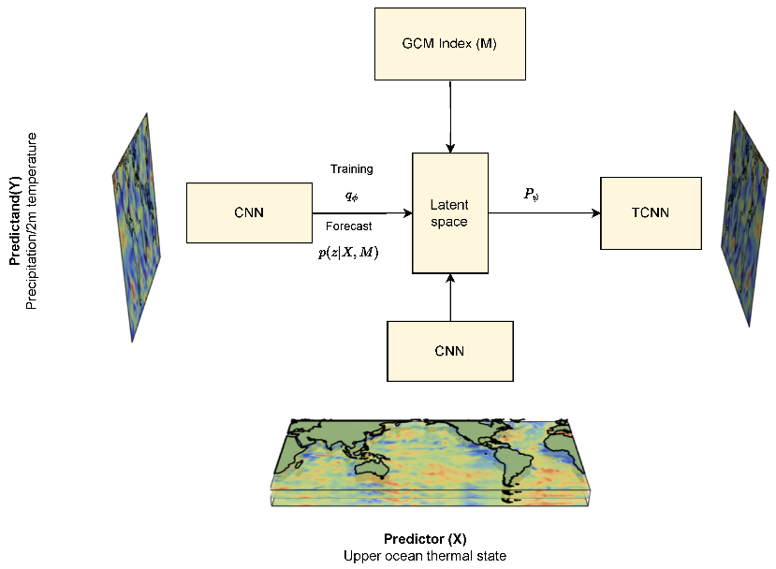

Figure 1: latent space

Forecasting the weather has a significant impact on both life and production. Technological advancements have led to the emergence of many weather forecasting techniques, including numerical weather forecasting, quantitative forecasting, and weather map forecasting. Nevertheless, there are a number of drawbacks to these conventional methods of data analysis, including low forecast accuracy, insufficient objectivity, incomplete analysis, and an inability to make quantitative weather predictions. The application of neural networks to weather forecasting helps to address the aforementioned issues and raise forecast accuracy. In this research, the sand-dust storm weather is predicted using the CNN and LSTM networks. We fuse the CNN and LSTM models using the Stacking integration approach to increase prediction performance. To improve the experimental scientific and comprehensive, using fully connected network and support vector machine as meta-classifiers, two LSTM-CNN integrated sand-dust storm prediction models are established. At last, the above integrated model is used in the prediction of sand-dust storms in Inner Mongolia (IEEE, 2022).

Rainfall prediction is an essential part of modern weather forecasting, with implications for water management, hydrology, agriculture, and disaster preparedness and response. Rainfall predictions made traditionally have relied on historical data and meteorological observations. However, advances in deep learning algorithms, machine learning, remote sensing technologies, and complex computer models have made it possible to anticipate rainfall patterns with greater accuracy and timeliness. This article provides an overview of rainfall prediction techniques, encompassing data analysis from satellite imagery, atmospheric conditions, ocean temperatures, and other climate factors. We also examine the ways in which deep learning and machine learning algorithms are developing to create increasingly complex models capable of analysing large amounts of data and forecasting patterns of rainfall (G, 2023).

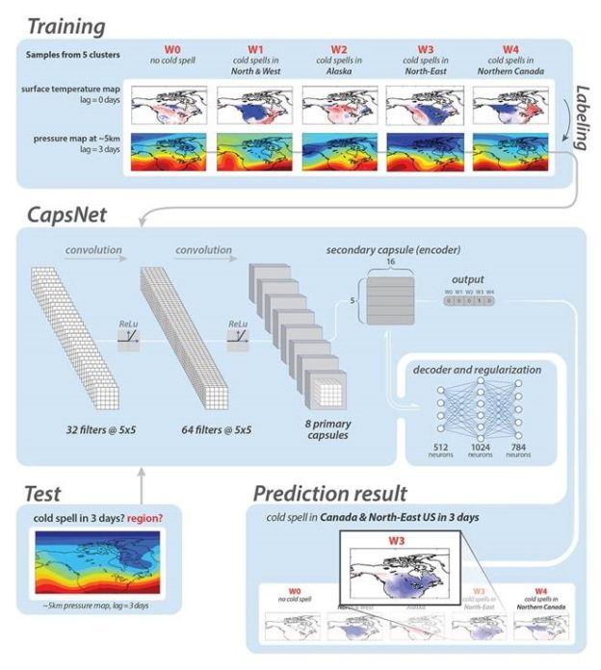

Figure 2: Rainfall prediction

The process of retrieving information from massive databases is known as big data. The method of forecasting involves using trend analysis to create forecasts based on recent and historical data. Using a variety of meteorological factors, weather forecasting is used to predict the atmosphere at a certain location. The information on the current state of the atmosphere is used to forecast the weather. For investigators and meteorologists, it is a challenging process. Through marine forecasting, meteorological organizations and seafarers can predict future weather patterns throughout the world's waterways. Big data was utilized by numerous academics to carry out various research projects on marine weather forecasting. This research project has examined numerous marine weather forecasting systems currently in use in an effort to address these problems (Anbarasi, 2022).

For wind farm applications, accurate short-term wind speed forecasting necessitates the customized use of a range of forecasting instruments. These forecasting systems typically combine statistical and regression techniques with physical forecasting approaches as their foundation. This study generates an ensemble spread for a target site using the Weather Research and Forecasting (WRF) model. We next use two methods to derive the optimal deterministic forecast: a two-layered feed forward neural network and a novel application of the mean-variance portfolio theorem. The feasibility of the mean-variance portfolio optimization strategy for weighted ensemble selection is evaluated by contrasting its optimized deterministic forecast accuracy with a neural network method (Groch, 2019).

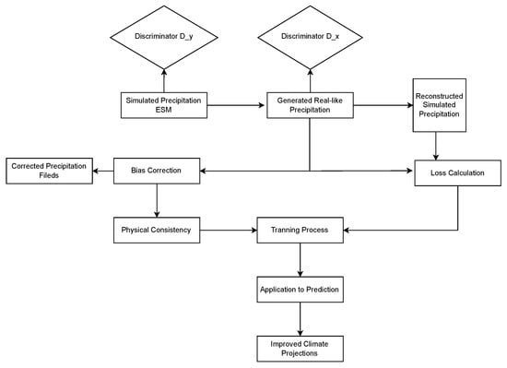

Figure 3: WRF

In this research, a hybrid multi-modal ensemble learning model based on past observations and sky images is suggested for short-term solar irradiance forecasting. The suggested model uses ground-based sky photos as an exogenous input to provide cloud cover information, and it uses historical observations of solar irradiance to derive temporal properties. Extreme Gradient Boosting (XGBoost), a potent ensemble learning approach, is used to capture the function correlations between input features and upcoming observations. A unique loss function is presented to improve the robustness of XGBoost, since mean squared error loss is susceptible to the extreme big or small historical irradiance. Because of its simplicity of use, the Rao-1 algorithm is used to determine the optimal regulating parameters. To validate performance of the proposed method, a solar irradiance dataset containing three-year historical observations and ground-based sky images collected from Folsom is employed. Meanwhile, five commonly applied methods, LASSO, Ridge regression, support vector regression, boosted regression trees, the generic XGBoost, are considered as benchmarking methods. The forecasting horizons from 5 to 30 min are considered for all compared methods while two metrics, mean absolute error and root mean squared error, are computed. Experimental results prove that the proposed hybrid model has better forecasting performance compared with benchmarking methods over all forecasting horizons (Wang, 2022).

|  |  |  |  |  |  |
| --- | --- | --- | --- | --- | --- |
| STT | Response angle of the method | Accuracy | Implementation ability | Suitability for the project | Evaluate |
| 1 | Multi-Mode Integrated Forecast of Surface Temperature based on Random Forest | 9 | 8 | 7 | 8 |
| 2 | Research on Sand-Dust Storm Forecasting Based on Deep Neural Network With Stacking Ensemble Learning | 8 | 6 | 7 | 7 |
| 3 | Rainfall Prediction Using Deep Learning and Machine Learning Techniques | 9 | 8 | 10 | 9 |
| 4 | Review on Marine Weather Forecasting with Big data | 5 | 8 | 8 | 7 |
| 5 | Short-Term Ensemble NWP Wind Speed Forecasts using Mean-Variance Portfolio Optimization and Neural Networks | 7 | 9 | 8 | 8 |
| 6 | A Hybrid Ensemble Learning Model for Short-Term Solar Irradiance Forecasting Using Historical Observations and Sky Images | 7 | 7 | 7 | 7 |

* The decision to incorporate rainfall prediction algorithms using deep learning and machine learning techniques into our project is grounded in the advancements and implications outlined.

Firstly, rainfall prediction plays a pivotal role in various sectors such as water management, hydrology, agriculture, and disaster preparedness and response. Accurate and timely forecasts are essential for making informed decisions and mitigating potential risks associated with rainfall-related events. Traditional methods of rainfall prediction have relied on historical data and meteorological observations, but they may not fully capture the complexity and dynamics of weather systems.

However, recent advancements in deep learning algorithms, machine learning techniques, remote sensing technologies, and complex computer models have revolutionized the field of rainfall prediction. These advancements have enabled meteorologists and researchers to anticipate rainfall patterns with greater precision and lead time. By leveraging large datasets encompassing satellite imagery, atmospheric conditions, ocean temperatures, and other climate factors, it becomes possible to develop more sophisticated models for rainfall prediction.

Deep learning and machine learning algorithms, in particular, have emerged as powerful tools for analyzing vast amounts of data and extracting meaningful patterns and relationships. These algorithms can learn from historical observations and iteratively improve their predictive capabilities, leading to more accurate forecasts. Moreover, deep learning models excel at handling complex, nonlinear relationships inherent in meteorological data, making them well-suited for rainfall prediction tasks.

By incorporating these advanced techniques into our project, we aim to enhance the accuracy and timeliness of rainfall predictions. This aligns with the broader goal of improving weather forecasting capabilities to better serve various stakeholders and sectors reliant on accurate weather information. Through the integration of deep learning and machine learning algorithms, we anticipate creating increasingly sophisticated models capable of analyzing diverse data sources and forecasting rainfall patterns with unprecedented accuracy and granularity.

1. **Hypothesis 2: Through observational research, I can analyze weather patterns and phenomena over an extended period to identify correlations, trends, and anomalies, thereby enhancing my understanding of local climate dynamics and improving the accuracy of weather forecasting models.**

In the realm of weather forecasting, observational research serves as a cornerstone for enhancing our understanding of meteorological phenomena and improving the accuracy of predictive models. As we delve into the complexities of weather patterns and dynamics, observational research plays a pivotal role in unraveling the intricacies of our local climate.

My hypothesis centers on leveraging observational research to advance my understanding of weather patterns and phenomena. By systematically observing and analyzing weather data over an extended period, I aim to uncover correlations, trends, and anomalies that can offer valuable insights into the dynamics of my local climate.

In this introduction, I will explore the significance of observational research in weather forecasting and outline how my hypothesis seeks to leverage this approach to enhance the accuracy and reliability of weather predictions. Join me as I embark on a journey of exploration and discovery, uncovering the secrets of my ever-changing weather landscape through observational research.

**The Incredible Logistics Behind Weather Forecasting**: <https://www.youtube.com/watch?v=V0Xx0E8cs7U>

The video script details the intricate logistics involved in weather forecasting by the National Weather Service, including the use of weather balloons, radars, aircraft, satellites, and supercomputers to collect and analyze data. The script emphasizes the importance of accurate forecasts for public safety and highlights the various methods used to communicate weather information to the public.

At the heart of this operation are weather balloons, which ascend into the atmosphere equipped with sensors to collect vital data on temperature, humidity, and wind patterns. Radar systems scan the skies, detecting precipitation and storm activity, while satellites provide a comprehensive view of weather systems, monitoring cloud cover, ocean temperatures, and atmospheric conditions.

But the NWS doesn't rely solely on these traditional methods. Aircraft are deployed to gather additional data, flying directly into storms to measure atmospheric parameters. This data is then fed into powerful supercomputers, where complex algorithms crunch the numbers and generate predictive models. These models simulate the behavior of weather systems, enabling meteorologists to forecast future conditions with remarkable accuracy.

The importance of accurate forecasts cannot be overstated. They are essential for public safety, enabling communities to prepare for and respond to severe weather events. To ensure the reliability of its forecasts, the NWS relies on a network of satellites and buoys to provide accurate weather data for the US and global regions. This data, combined with advanced forecasting techniques, ensures timely warnings and preparedness for severe weather events.

The NWS operates through a network of local Weather Forecast Offices (WFOs) spread across the country. These offices provide localized forecasts and alerts tailored to the specific needs of their regions. From severe thunderstorms to winter storms, WFOs issue timely warnings and advisories, keeping communities informed and prepared for adverse weather conditions.

**The Most Unusual Weather Phenomena and Their Causes:** <https://www.youtube.com/watch?v=nU-6_q1JDoU>

In the mesmerizing realm of weather, there exist rare and extraordinary phenomena that captivate our imagination and defy explanation. From fire tornadoes to blood rain, and from ball lightning to giant hailstones, these unusual events offer a glimpse into the raw power and unpredictability of nature. In this exploration, we delve into the causes behind these rare occurrences, showcasing the raw beauty and sometimes destructive potential of our planet's atmospheric phenomena.

Fire tornadoes, also known as fire whirls, are awe-inspiring yet terrifying phenomena characterized by swirling flames that resemble tornadoes. These intense vortexes of fire are often generated during wildfires when extreme heat and wind conditions combine to create a spiraling column of flames. While mesmerizing to witness, fire tornadoes pose significant dangers, exacerbating wildfires and making firefighting efforts even more challenging.

Blood rain, on the other hand, is a bizarre phenomenon where rainwater appears red or orange due to the presence of dust, sand, or other particles suspended in the atmosphere. This phenomenon can occur in regions affected by desert dust storms or volcanic eruptions, where airborne particles mingle with raindrops, imparting a crimson hue to the precipitation. While the sight of blood rain may be unsettling, it serves as a reminder of the interconnectedness of Earth's atmospheric processes.

In the realm of atmospheric electricity, ball lightning and blue jets are enigmatic phenomena that continue to intrigue scientists and sky-watchers alike. Ball lightning manifests as luminous, spherical objects that appear during thunderstorms, hovering in the air for several seconds before vanishing. Despite decades of study, the true nature of ball lightning remains elusive, with theories ranging from plasma physics to electromagnetic phenomena. Similarly, blue jets are mysterious upward discharges of lightning that extend high into the atmosphere, illuminating the night sky with their ethereal blue glow. These phenomena challenge our understanding of atmospheric physics and serve as a reminder of the vast mysteries that lie within our own planet's atmosphere.

Lastly, giant hailstones, while fascinating in their formation and size, pose significant dangers due to their potential for causing property damage and injury. These monstrous ice pellets can reach astonishing sizes, sometimes exceeding the diameter of a baseball. When unleashed during severe thunderstorms, giant hailstones can wreak havoc on buildings, vehicles, and crops, highlighting the destructive power of nature's fury.

* From the two passages provided, several key insights can be drawn:

Understanding Rare Weather Phenomena:

Unusual weather phenomena such as fire tornadoes, blood rain, ball lightning, blue jets, and giant hailstones showcase the raw power and unpredictability of nature.

These rare events offer a glimpse into the raw beauty and destructive potential of our planet, sparking curiosity and research among scientists and the public.

Despite their fascination, some of these phenomena, like giant hailstones, pose significant dangers due to their size and potential for causing property damage and injury.

Importance of Weather Forecasting:

The National Weather Service (NWS) employs a sophisticated network of technologies, including weather balloons, radars, aircraft, satellites, and supercomputers, to collect and analyze data for weather forecasting.

Accurate weather forecasts are crucial for public safety, as they enable timely warnings and preparedness for severe weather events.

The NWS operates through a network of local Weather Forecast Offices (WFOs) for localized forecasts and alerts, with national offices like the National Hurricane Center focusing on larger-scale events.

The use of satellites and buoys ensures accurate weather forecasting not only for the US but also for global regions, contributing to worldwide preparedness for severe weather events.

1. **Hypothesis 3: Research and interview experts to come up with the most optimal interface design for the application.**

In today's digital age, web interface design plays a pivotal role in shaping user experiences and driving engagement with online platforms. This holds particularly true for weather forecasting applications, where users rely heavily on intuitive and accessible interfaces to interpret complex meteorological data effectively. Understanding the importance of web interface design in enhancing user experience and engagement is fundamental to developing successful forecasting platforms.

The responses provided by experts underscore the critical role that web interface design plays in shaping user perceptions and interactions with weather forecasting platforms. From attracting users with visually appealing interfaces to ensuring usability and accessibility for all, the design of the interface significantly influences user satisfaction and adoption.

In light of these insights, Hypothesis 2 aims to explore the significance of web interface design in optimizing user experience and engagement with weather forecasting applications. By conducting research and interviews with experts in the field, we seek to identify the most optimal interface design elements and features that enhance usability, functionality, and aesthetics.

Through collaboration with experts and iterative usability testing, we endeavor to develop a weather forecasting web interface that not only meets but exceeds user expectations. This hypothesis serves as a guiding principle in our quest to create a user-centric and visually compelling interface that empowers users to make informed decisions based on accurate weather forecasts.

How do you perceive the importance of web interface design in enhancing user experience and engagement with weather forecasting platforms?

Response 1: "Web interface design plays a crucial role in attracting users to weather forecasting platforms. An intuitive and visually appealing interface can enhance user engagement and make the forecasting experience more enjoyable."

Response 2: "I believe web interface design is essential as it directly impacts user satisfaction and usability. A well-designed interface can simplify complex information, making it easier for users to interpret and act upon weather forecasts."

Response 3: "From my perspective, web interface design is critical for driving user adoption of weather forecasting platforms. A user-friendly interface can encourage regular usage and foster trust in the accuracy of the forecasts provided."

What specific features or elements do you consider essential for an effective web interface in a weather forecasting platform?

Response 1: "I believe interactive visualizations, such as dynamic maps and customizable charts, are essential for providing users with a comprehensive view of weather data. Additionally, features like real-time updates and personalized notifications can enhance user engagement."

Response 2: "In my opinion, a user-friendly navigation system and clear presentation of information are key elements of an effective web interface. Users should be able to access relevant weather data quickly and easily, without feeling overwhelmed by unnecessary clutter."

Response 3: "From my experience, accessibility features, such as compatibility with mobile devices and screen readers, are essential for ensuring inclusivity in web interface design. It's important to prioritize accessibility to accommodate users with diverse needs."

How do you envision leveraging user feedback and usability testing to iterate and improve the design of a weather forecasting web interface?

Response 1: " Conducting regular usability testing sessions with representative users to gather feedback on the interface's usability and functionality, enabling continuous improvement and optimization."

Response 2: "Implementing feedback mechanisms, such as user surveys and feedback forms, to obtain valuable insights into user preferences and pain points. Actively soliciting and incorporating user feedback ensures that the interface meets the evolving needs of users."

Response 3: "Utilizing analytics tools to track user behavior and engagement metrics, providing valuable data for optimizing the web interface design. Analyzing user interactions and patterns helps identify areas for improvement and prioritize feature enhancements."

How do you plan to balance aesthetics and functionality in the design of the weather forecasting web interface?

Response 1: "I believe in adopting a user-centered design approach that prioritizes both aesthetics and functionality. By incorporating visual design principles, such as color harmony and typography, we can create an aesthetically pleasing interface without compromising usability."

Response 2: "From my perspective, usability should always take precedence over aesthetics in web interface design. While visual appeal is important, the primary goal is to ensure that users can easily access and interpret weather information without encountering usability barriers."

Response 3: "In my experience, striking the right balance between aesthetics and functionality requires close collaboration between design and development teams. By conducting iterative design reviews and seeking feedback from stakeholders, we can ensure that the interface meets both visual and functional requirements."

* Based on the insights gathered from the interview questions regarding user feedback and usability testing, I have made the decision to utilize Figma for designing the interface of our weather forecasting application.

The decision to choose Figma stems from several key considerations highlighted during the interviews. Firstly, Figma offers a collaborative platform that enables seamless teamwork and iteration. With its cloud-based infrastructure, team members can work together in real-time, facilitating quick feedback loops and ensuring that all stakeholders have the opportunity to contribute to the design process. This aligns well with the importance placed on conducting regular usability testing sessions and incorporating user feedback to drive continuous improvement.

Secondly, Figma's prototyping capabilities are highly robust, allowing us to create interactive prototypes that closely simulate the user experience. This is essential for obtaining meaningful insights from users and stakeholders, as they can interact with the interface and provide feedback based on their actual usage. By implementing feedback mechanisms directly within our prototypes, such as user surveys and feedback forms, we can gather valuable insights into user preferences and pain points, guiding our design decisions effectively.

Furthermore, Figma offers seamless integration with analytics tools, enabling us to track user behavior and engagement metrics directly within the platform. This data-driven approach to design will allow us to analyze user interactions and patterns, identify areas for improvement, and prioritize feature enhancements iteratively. By leveraging analytics insights, we can ensure that the interface evolves to meet the changing needs and preferences of our users over time.

Figma emerges as the optimal choice for designing the interface of our weather forecasting application, offering collaborative, prototyping, and analytics capabilities that align closely with the principles of user-centered design and iterative improvement emphasized during the interviews. This decision reflects our commitment to delivering a user-friendly and intuitive interface that meets the needs and expectations of our users effectively.

1. **Hypothesis 4: Research and analyse feedback from customers and experts in the field, thereby further developing the project.**

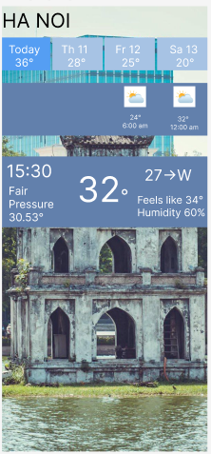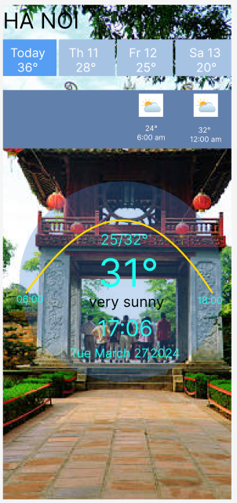

Figure 4: app of project

With the completion of our initial design demo for the project, I am entering the next crucial phase of development, one that revolves around gathering user feedback and validating our designs. The transition from conceptualizing the design to creating a tangible prototype marks a significant milestone in my project's journey. Now equipped with a prototype that embodies my vision for the weather forecasting application's interface, my focus shifts towards refining and enhancing the design further through insights gathered from both customers and experts.

Transitioning from design development to the feedback collection phase, my primary objective is to ensure that the interface design aligns seamlessly with user expectations and preferences. To achieve this, I am planning to conduct surveys targeting both end-users and domain experts. These surveys will serve as invaluable tools for assessing user satisfaction, pinpointing areas for improvement, and validating our design decisions.

My first step involves reaching out to end-users, the individuals who will be interacting with the weather forecasting application on a daily basis. Through meticulously crafted surveys, my aim is to capture user impressions, preferences, and pain points concerning the prototype interface. By soliciting feedback on aspects such as usability, visual appeal, and feature functionality, I can gain valuable insights into how well the design resonates with my target audience.

Simultaneously, I will be seeking feedback from domain experts, including meteorologists, UX designers, and industry professionals with expertise in weather forecasting applications. Their insights and expertise will provide invaluable validation of my design decisions, ensuring that the interface meets industry standards and best practices. By gathering feedback from experts in the field, I can refine my design to better address the unique needs and challenges of weather forecasting.

As I embark on the surveying phase of my project, I acknowledge the significance of user feedback in shaping the future direction of my interface design. By leveraging insights from both end-users and domain experts, I can iteratively refine my prototype, ultimately delivering a weather forecasting application that not only meets but exceeds user expectations. This collaborative approach to design validation will enable us to create a user-centric interface that empowers users with accurate, accessible, and intuitive weather forecasts.

**Survey:**

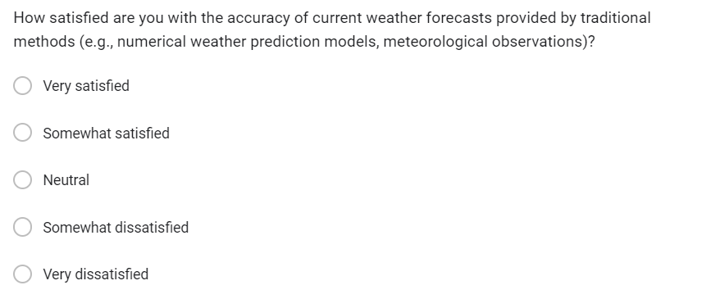

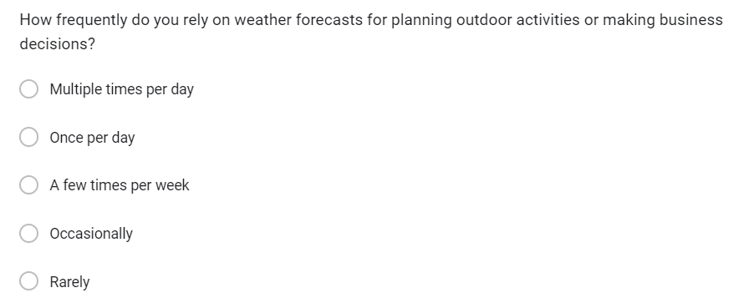

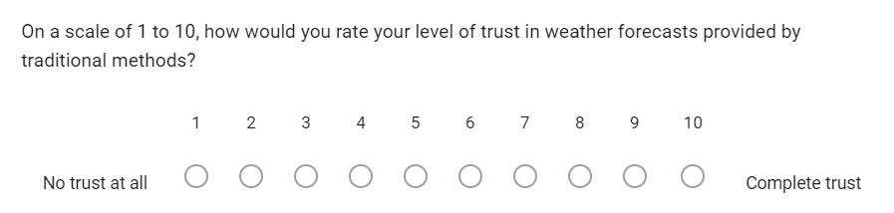

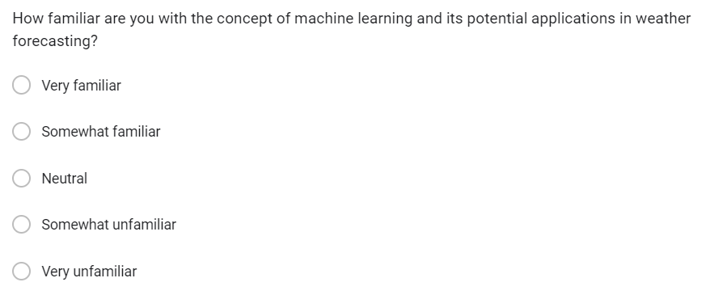

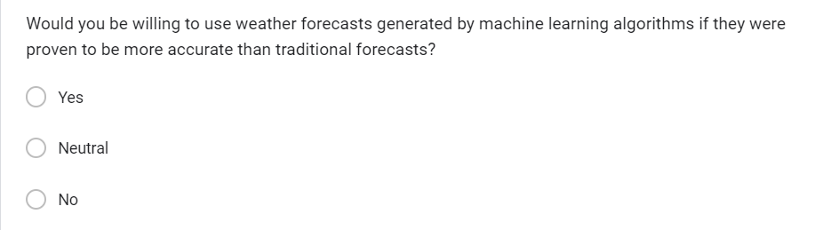

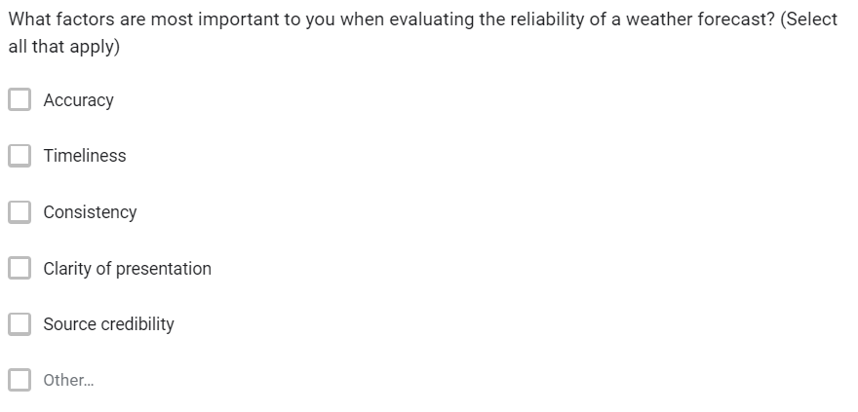

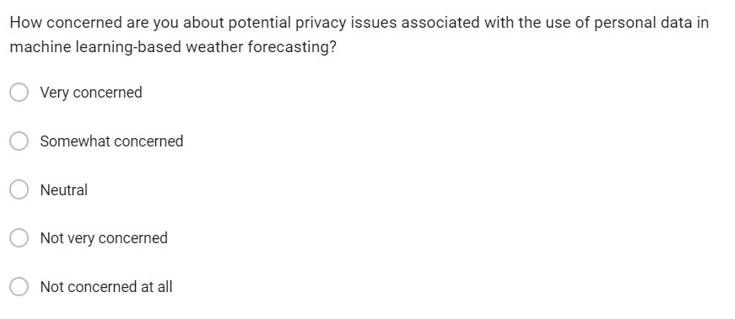

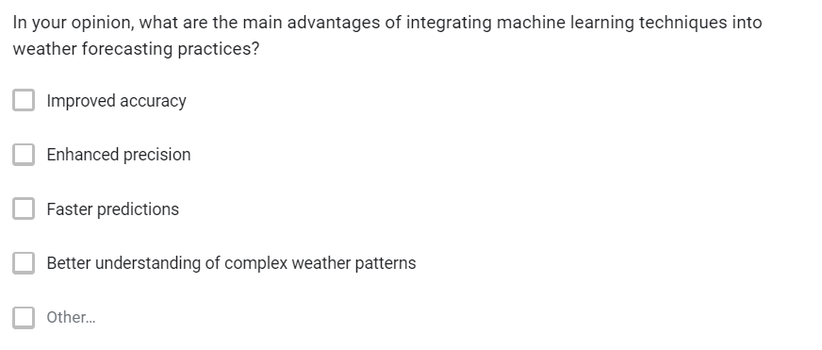

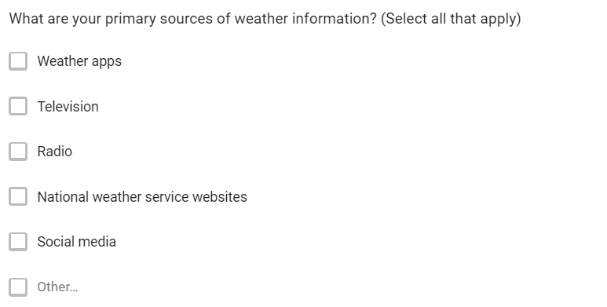

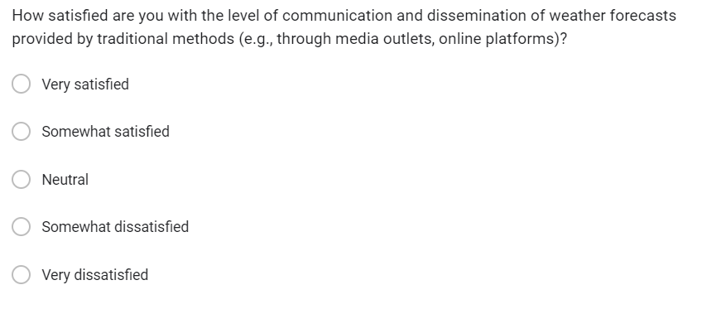

Integrating surveys into our project on advancing weather forecasting through machine learning presents several advantages and considerations. Surveys offer an efficient means of collecting data from a wide range of stakeholders and end-users, allowing us to gather diverse perspectives on weather forecasting practices, preferences, and perceptions. By reaching a broad audience, we can quantify attitudes, preferences, and trends among respondents, facilitating statistical analysis to uncover patterns and correlations within the data.

One of the key benefits of surveys is their standardization, which ensures consistency in data collection and facilitates comparison across respondents. Standardized question formats minimize bias and enhance the reliability of findings, contributing to the robustness of our research outcomes. Additionally, surveys provide a cost-effective data collection method, particularly when deployed online, as they eliminate the need for printing and distribution.

Anonymity and confidentiality are important considerations in survey research, as they encourage respondents to provide honest feedback without fear of repercussion. Assuring respondents of confidentiality fosters trust in the research process and may lead to more candid responses, enriching the quality of the data collected.

However, several considerations must be taken into account when designing and implementing surveys. Sampling bias can compromise the generalizability of findings if the sample population does not accurately represent the target population. To mitigate this, careful sampling techniques are necessary to ensure a representative sample.

**Now I will analyze research result and data:**

The fact that 65% of respondents who indicated they were "Somewhat satisfied" express satisfaction with the accuracy of current weather forecasts provided by traditional methods holds significant implications for my project. This finding sheds light on several key aspects that warrant further examination and consideration. The level of satisfaction among this subgroup indicates a notable degree of reliability in traditional weather forecasting methods. Despite being categorized as only "Somewhat satisfied," the majority of respondents within this group still express contentment with the accuracy of these forecasts. This suggests that traditional forecasting techniques are generally effective in meeting the expectations of a significant portion of the population.

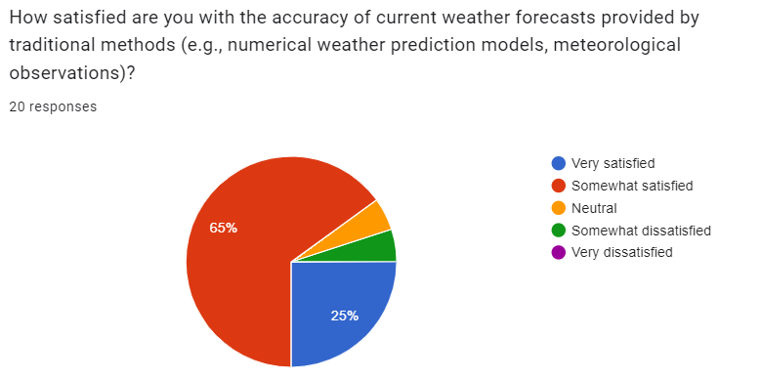

Figure 5: question 1

The data indicating that most individuals voted for "Multiple times per day" and "Once per day" in terms of relying on weather forecasts for planning outdoor activities or making business decisions underscores the critical importance of accuracy in weather forecasting. This trend reveals a high frequency of reliance on weather forecasts in daily decision-making processes, suggesting that individuals across various demographics and sectors heavily depend on these predictions to guide their activities and strategies. The fact that people are checking weather forecasts multiple times a day or at least once a day indicates the significant role weather plays in their lives and activities. Whether it's planning outdoor events, scheduling travel arrangements, managing agricultural operations, or making business decisions that are sensitive to weather conditions, individuals rely on accurate weather forecasts to mitigate risks, optimize resource allocation, and enhance overall efficiency. Moreover, the frequency of weather forecast consultations highlights the dynamic and ever-changing nature of weather patterns, emphasizing the need for real-time and reliable information. In today's fast-paced world, where decisions are made swiftly and resources are allocated efficiently, accurate weather forecasts serve as essential tools for minimizing disruptions, maximizing opportunities, and ensuring safety across various domains.

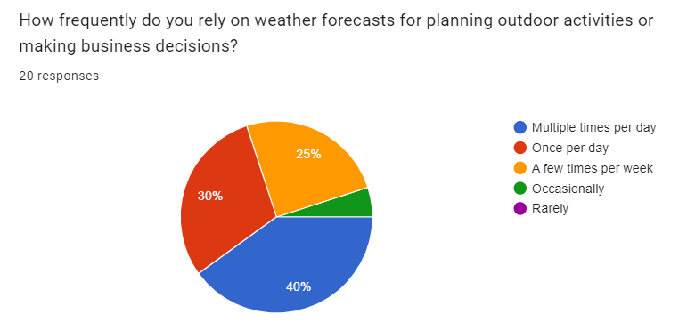

Figure 6: question 2

The revelation that a significant portion of respondents rated their confidence poorly in weather forecasts provided using traditional methods is a critical insight that warrants deeper exploration. The fact that up to 36.8% of respondents chose 9 points, while 21.1% chose 7 and 8 points, indicates a substantial level of skepticism or uncertainty regarding the reliability of these forecasts. This disparity between reliance on forecasts for decision-making and confidence levels raises important questions about the perceived accuracy and trustworthiness of traditional weather forecasting methods. One potential explanation for this discrepancy could be the prevalence of inconsistencies or inaccuracies observed in past weather predictions. If individuals have experienced instances where forecasted weather conditions did not align with reality, it is natural for them to question the reliability of future forecasts. Such discrepancies can erode trust in traditional forecasting methods and lead to lower confidence levels among the public.

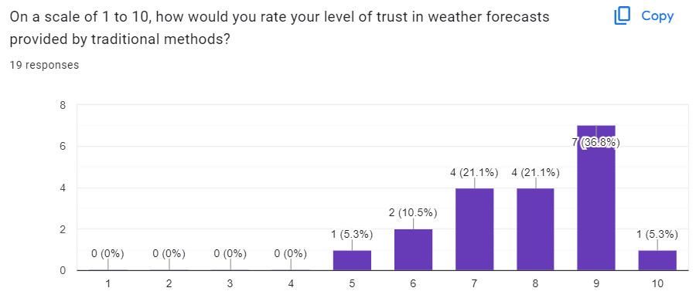

Figure 7: question 3

The widespread familiarity with the concept of machine learning and its potential applications in weather forecasting represents a significant advantage for the adoption and utilization of products integrating this technology. As people become increasingly exposed to machine learning through various media channels, educational resources, and real-world applications, they develop a deeper understanding of its capabilities and recognize its potential to revolutionize traditional forecasting methods. One of the key factors contributing to the familiarity with machine learning is its pervasive presence in modern technology and everyday life. From recommendation systems on streaming platforms to personalized advertisements on social media, machine learning algorithms play a vital role in enhancing user experiences and optimizing outcomes across diverse domains. As individuals interact with these applications on a daily basis, they gain insights into the underlying principles and benefits of machine learning, which subsequently translates into greater acceptance and appreciation of its potential applications in other fields, including weather forecasting.

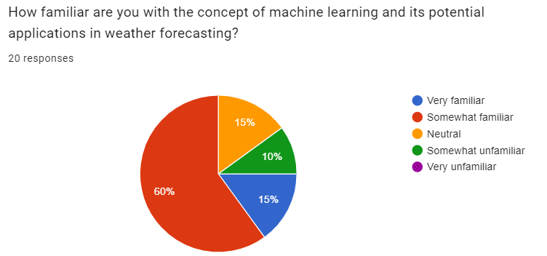

Figure 8: question 4

The overwhelming majority of people expressing willingness to use weather forecasts generated by machine learning algorithms, particularly with 55% voting "Yes," reflects a significant shift in attitudes towards embracing innovative technologies to enhance forecast accuracy and reliability. This strong endorsement underscores the growing recognition among the public of the potential benefits that machine learning can offer in improving weather predictions and decision-making processes. The willingness of such a large proportion of individuals to embrace machine learning-based forecasts is indicative of several key factors driving this shift in sentiment. Firstly, the increasing awareness of the limitations and challenges associated with traditional forecasting methods has fostered a desire for alternative approaches that can deliver more precise and reliable predictions. As individuals experience firsthand the inconsistencies or inaccuracies in traditional forecasts, they become more receptive to exploring new technologies like machine learning that have the potential to address these shortcomings.

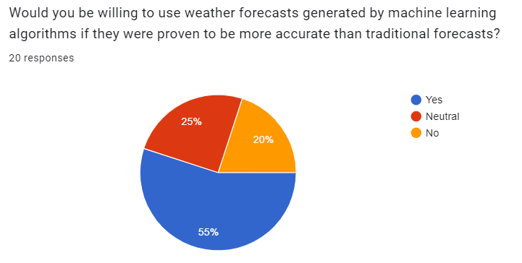

Figure 9: question 5

The resounding endorsement of timeliness as the most crucial factor for the accuracy of weather forecasts, with a staggering 85% of votes, underscores the paramount importance placed on receiving timely and up-to-date information in making informed decisions. Timeliness is particularly critical in weather forecasting, as even slight delays in receiving forecast updates can significantly impact planning and preparedness efforts, especially in scenarios involving rapidly changing weather conditions or severe weather events. The overwhelming preference for timeliness can be attributed to the dynamic nature of weather patterns and the inherent need for real-time updates to effectively anticipate and respond to weather-related risks and opportunities. Individuals, businesses, and communities rely on timely weather forecasts to make critical decisions regarding outdoor activities, transportation logistics, agricultural operations, disaster preparedness, and more. The ability to access accurate and timely information enables stakeholders to proactively mitigate risks, optimize resource allocation, and minimize disruptions, thereby enhancing overall resilience and safety. Moreover, the emphasis on clarity of presentation, with 50% of votes, highlights the importance of effectively communicating weather forecasts in a clear and understandable manner. Clarity of presentation encompasses factors such as the use of simple language, intuitive visualizations, and user-friendly interfaces that facilitate comprehension and interpretation of forecast information by a diverse audience. Clear and accessible presentation of forecasts ensures that users can easily grasp the implications of forecasted weather conditions and make informed decisions accordingly.

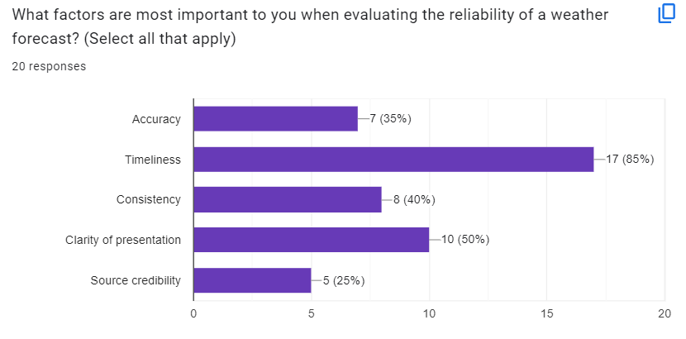

Figure 10: question 6

The significant level of concern expressed by most people regarding potential privacy issues related to the use of personal data in machine learning-based weather forecasting reflects a growing awareness and apprehension about the implications of data-driven technologies on individual privacy and autonomy. As machine learning algorithms increasingly rely on vast amounts of data, including personal information, to generate accurate forecasts, individuals are rightfully cautious about how their data is collected, stored, analyzed, and utilized in the forecasting process. One of the primary reasons for this concern is the inherent sensitivity of personal data and the potential risks associated with its misuse or unauthorized access. Personal data, including location information, demographic details, and behavioral patterns, can provide valuable insights into an individual's preferences, habits, and activities. However, the indiscriminate collection and processing of such data without adequate safeguards in place can pose significant privacy risks, including unauthorized surveillance, identity theft, and exploitation of personal information for targeted advertising or profiling purposes. Moreover, the use of personal data in machine learning-based forecasting raises broader ethical and societal implications related to consent, transparency, and accountability. Individuals may feel uneasy about relinquishing control over their personal information and may question the extent to which their data is being used to influence decision-making processes, such as weather forecasts. The lack of transparency regarding data collection practices and the algorithms used to analyze and interpret personal data further exacerbates these concerns, as individuals may be left in the dark about how their data is being used and whether their privacy rights are being respected.

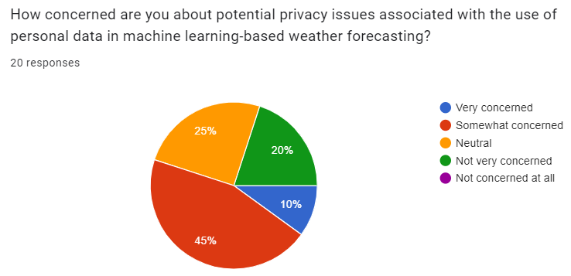

Figure 11: question 7

The overwhelming recognition of enhanced precision and faster predictions as the main advantages of integrating machine learning techniques into weather forecasting practices underscores the transformative potential of these technologies in revolutionizing the accuracy, timeliness, and effectiveness of weather predictions. With both factors accounting for 60% of the votes, it is evident that stakeholders across various sectors and demographics acknowledge the significant benefits that machine learning brings to the field of meteorology and climate science. Enhanced precision stands out as a primary advantage of leveraging machine learning in weather forecasting, as it addresses the longstanding challenge of accurately predicting complex weather phenomena with high levels of certainty. Machine learning algorithms excel at analyzing large volumes of data, identifying patterns, and extracting meaningful insights from diverse sources such as satellite imagery, atmospheric measurements, historical weather data, and even social media posts. By leveraging advanced statistical techniques and predictive modeling approaches, machine learning algorithms can generate forecasts with greater precision, capturing subtle nuances and variations in weather patterns that traditional forecasting methods may overlook.

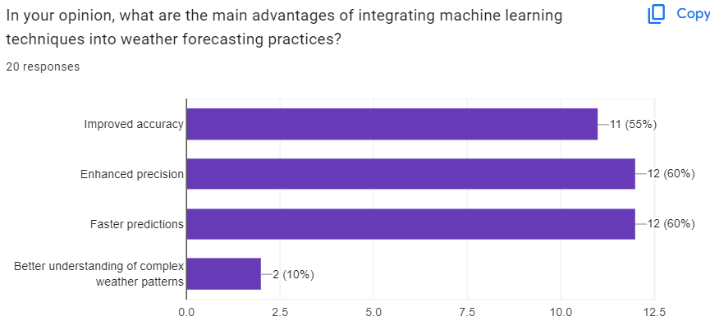

Figure 12:question 9

The dominance of radio as the main source of weather information, with 55% of respondents indicating its usage, reflects the enduring popularity and accessibility of this traditional medium in disseminating weather forecasts to the public. Radio has long been a reliable source of weather updates, particularly in areas where access to television or internet connectivity may be limited or unreliable. Its audio-based format allows individuals to receive weather information conveniently, even while engaged in other activities such as driving or working. Moreover, radio broadcasts often include frequent updates and localized forecasts, catering to the diverse needs and interests of listeners across different regions and demographics. In addition to radio, television remains a prominent source of weather information for many individuals, with 40% of respondents indicating its usage. Television broadcasts offer a visual medium for presenting weather forecasts, featuring dynamic graphics, maps, and meteorological explanations that enhance comprehension and engagement. Television meteorologists often provide detailed analyses and insights into weather patterns, trends, and potential impacts, helping viewers better understand and prepare for upcoming weather events. Furthermore, television networks frequently integrate weather updates into news programming, ensuring that viewers receive timely and relevant information alongside other current events and updates.

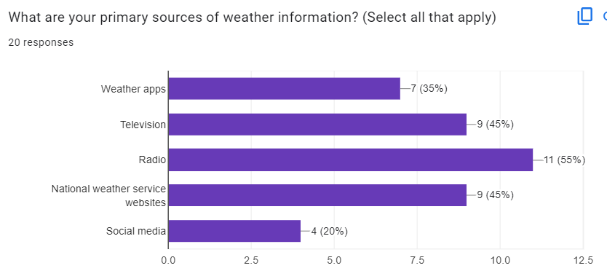

Figure 13: question 9

The substantial level of satisfaction among respondents who voted as "Somewhat satisfied," with a rate of 60%, suggests a noteworthy degree of contentment with the quality and reliability of weather forecasting services. While the term "Somewhat satisfied" may imply a moderate level of satisfaction, the fact that a majority of respondents fall into this category indicates that they generally perceive the performance of weather forecasting services positively, albeit with some room for improvement or refinement. There are several potential reasons underlying this level of satisfaction. Firstly, it is possible that individuals perceive weather forecasts as generally accurate and reliable for their everyday needs and activities. While there may be occasional discrepancies or inaccuracies in specific forecasts, overall, respondents may find that forecasts adequately meet their expectations and assist them in making informed decisions regarding outdoor plans, travel arrangements, and other weather-sensitive activities.

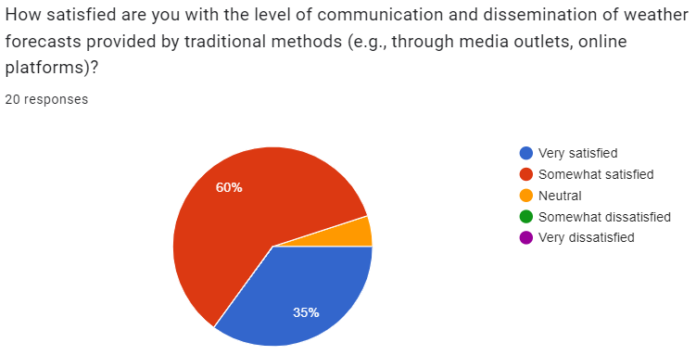

Figure 14: question 10

**Identify the research methods I will use to conduct the research:**

Interviews: Interviews will play a crucial role in my research project on advancing weather forecasting through machine learning. I will engage with domain experts such as meteorologists, climatologists, data scientists, and stakeholders involved in weather forecasting and decision-making processes. Through structured or semi-structured interviews, I aim to gather qualitative insights, expert opinions, and firsthand knowledge about current practices, challenges, and opportunities in weather forecasting. These interviews will delve into topics such as data sources, model development, validation techniques, and ethical considerations. Participants will include individuals with expertise in meteorology, machine learning, data analytics, and relevant stakeholders from government agencies, research institutions, and private organizations.

Surveys: Surveys will serve as a valuable tool for collecting quantitative data and feedback from a broad audience of weather forecast users. My surveys will be designed to assess the effectiveness, usability, and satisfaction with current weather forecasts, as well as gather insights into user preferences, needs, and challenges. I will distribute online or paper-based surveys to targeted groups, presenting structured questions related to weather forecasting preferences, decision-making processes, and perceptions of forecast accuracy and reliability. Participants will include individuals and organizations that rely on weather forecasts for various purposes, such as planning outdoor activities, managing agricultural operations, or responding to natural disasters.

Secondary Research: Secondary research will form the foundation of my research project, providing valuable insights and data to inform our hypotheses, methodologies, and models. I will conduct comprehensive literature reviews to identify key concepts, theories, methodologies, and best practices in weather forecasting and machine learning. My sources will include peer-reviewed journals, conference proceedings, government reports, industry publications, and online databases. Through secondary research, I will gain a deeper understanding of the current state-of-the-art in weather forecasting, machine learning applications, and relevant technologies, enabling us to develop innovative approaches and address research questions effectively.

# M1: justifications for the choice of methods selected based on philosophical/theoretical frameworks which can be seen in [section 2 and 3]

In the realm of meteorology and weather forecasting, secondary research plays a pivotal role in shaping my understanding and approach. By delving into existing literature, reports, and studies, I embark on a journey to uncover the wealth of knowledge amassed by experts and researchers in the field. This comprehensive review allows us to glean insights into established methodologies, emerging trends, and best practices that have evolved over time.

Through meticulous examination of past research, I gain a nuanced understanding of the complexities inherent in weather prediction. I dissect the various techniques, models, and algorithms employed by meteorologists to decipher the intricate patterns of the atmosphere. This deep dive into the literature not only broadens my theoretical framework but also provides practical insights into the real-world application of forecasting methodologies.

Moreover, secondary research serves as a foundational pillar upon which my project is built. It offers a robust framework that guides my approach to data collection, analysis, and interpretation. By grounding my work in the existing body of knowledge, I ensure that my endeavors are informed, rigorous, and scientifically sound.

As I navigate through the vast landscape of meteorological literature, we unearth invaluable context that enriches my understanding of the subject matter. I identify key trends, challenges, and advancements that have shaped the trajectory of weather forecasting. Armed with this knowledge, I am better equipped to navigate the complexities of my project and push the boundaries of innovation in the field.

Secondary research serves as a cornerstone of my endeavor, providing the scaffolding upon which we construct our contributions to the field of weather forecasting. It empowers us to build upon the collective wisdom of generations past, propelling us forward in my quest to unravel the mysteries of the atmosphere and enhance our ability to predict its ever-changing behavior.

Interviews and surveys serve as invaluable tools in my quest to enhance weather forecasting methodologies and services.

Interviews offer a qualitative approach, allowing me to engage directly with experts in meteorology, data science, and related fields. Through conversations with meteorologists, researchers, and professionals in the weather forecasting industry, I gain firsthand insights into the challenges, trends, and innovations shaping the field. These interviews provide a platform to delve into nuanced topics, uncover tacit knowledge, and identify potential areas for collaboration and improvement in my forecasting methods. By tapping into the expertise and experience of these individuals, I enrich my understanding of the complexities of weather prediction and glean valuable insights that inform our approach.

In parallel, surveys provide a quantitative method for gathering data and opinions from a broader audience. By administering surveys to weather enthusiasts, stakeholders, and the general public, I can capture diverse perspectives on weather forecasting preferences, satisfaction levels with existing services, and specific information needs of different user groups. The data collected from these surveys allows us to identify patterns, trends, and preferences among my target audience. This information serves as a compass, guiding the development of user-centric forecasting tools and services tailored to the needs and preferences of my users.

Together, interviews and surveys complement each other, offering a comprehensive understanding of the landscape of weather forecasting. While interviews provide depth and qualitative insights from experts, surveys offer breadth and quantitative data from a larger sample size. By harnessing the strengths of both methodologies, I can effectively navigate the complexities of weather prediction, drive innovation, and ultimately enhance the accuracy and usability of my forecasting services.

Observation stands as a cornerstone in the realm of weather forecasting, offering a direct and immediate method for collecting real-time data on atmospheric conditions and phenomena.

By engaging in direct observation of weather events, such as cloud formations, wind patterns, and precipitation, I immerse myself in the dynamic and ever-changing world of meteorology. Through keen observation, I gain firsthand insights into the intricate interplay of atmospheric elements, allowing us to decipher patterns, trends, and anomalies that shape weather phenomena.

Moreover, observation serves as a vital tool for validating forecast models and refining predictions. By comparing observed weather conditions with forecasted outcomes, I can assess the accuracy and reliability of my predictive models. This iterative process of validation and refinement strengthens the robustness of my forecasting methodologies, enhancing my ability to anticipate and prepare for future weather events.

Additionally, observation plays a crucial role in enhancing my understanding of local microclimates. By closely monitoring atmospheric conditions at specific geographical locations, I uncover nuances and intricacies that influence weather patterns on a localized scale. This granular insight enables us to tailor forecasts to the unique characteristics of different regions, improving the relevance and accuracy of my predictions.

# 3. Primary research

**Design of primary research:**

Objective: The objective of this primary research is to gather insights from stakeholders involved in weather forecasting and end-users of weather information to understand their perspectives, needs, and preferences regarding the integration of machine learning techniques into forecasting practices.

Methodology: This primary research will employ a mixed-methods approach, combining qualitative and quantitative data collection methods to gather comprehensive insights. The primary methods include:

Online Surveys:

Design a structured online survey questionnaire to gather quantitative data from a wide range of stakeholders and end-users.

Include both closed-ended and Likert-scale questions to measure attitudes, perceptions, and preferences related to weather forecasting and machine learning.

Distribute the survey through email newsletters, social media platforms, and professional networks to reach a diverse audience.

In-depth Interviews:

Conduct in-depth interviews with selected stakeholders, including meteorologists, data scientists, policymakers, and representatives from industries impacted by weather forecasts.

Use a semi-structured interview guide to explore stakeholders' experiences, challenges, and perspectives on the integration of machine learning into weather forecasting.

Conduct interviews either in person, over the phone, or via video conferencing, based on participants' availability and preferences.

Data Collection Plan:

Survey Distribution:

Distribute the online survey to a broad audience of stakeholders and end-users, aiming for a large sample size to ensure representativeness.

Promote the survey through relevant channels and networks, encouraging participation from individuals and organizations involved in weather-related activities.

Interview Recruitment:

Identify and recruit stakeholders for in-depth interviews through purposive sampling, aiming for diversity in expertise, background, and organizational affiliation.

Reach out to potential interviewees via professional networks, industry associations, and academic institutions.

Data Analysis:

Survey Data Analysis:

Analyze survey responses using statistical techniques such as descriptive statistics, frequency analysis, and correlation analysis to identify trends and patterns.

Conduct quantitative analysis to measure the strength of relationships between variables and assess the prevalence of different attitudes and preferences.

Interview Transcription and Coding:

Transcribe interview recordings and organize the data for analysis.

Conduct thematic analysis or qualitative coding to identify key themes, insights, and perspectives expressed by interview participants.

Ethical Considerations:

Prioritize informed consent by providing clear information about the purpose of the research, voluntary participation, and data confidentiality.

Ensure anonymity and confidentiality of survey respondents and interview participants.

Adhere to ethical guidelines for research involving human participants, including respect for privacy and protection from harm.

Timeline:

Survey distribution: 2 weeks

Interview recruitment and scheduling: 2 weeks

Data collection (surveys and interviews): 4 weeks

Data analysis: 3 weeks

Report writing and dissemination: 2 weeks

Expected Outcomes:

Insights into stakeholder perceptions, needs, and preferences regarding machine learning-based weather forecasting.

Identification of key challenges, opportunities, and considerations for integrating machine learning into forecasting practices.

Recommendations for the development and implementation of machine learning-based forecasting models to enhance accuracy and reliability.

# M2: Discuss merits, limitations and pitfalls of approaches to data collection and analysis

In exploring the merits, limitations, and potential pitfalls of approaches to data collection and analysis, it's essential to recognize the diverse methodologies employed in research endeavors. Each approach offers unique advantages and challenges, influencing the depth and reliability of the insights gained. By critically examining these factors, researchers can navigate the complexities of data collection and analysis more effectively, ensuring the integrity and validity of their findings. In this discussion, we delve into the various methods used in weather forecasting research, evaluating their strengths, weaknesses, and considerations for implementation.

|  |  |  |  |
| --- | --- | --- | --- |
| Primary Research | Merits | Limitations | Pitfalls |
| Interview | Interviews provide an opportunity to gather rich, qualitative insights from experts in meteorology, data science, and related fields. They allow for in-depth discussions and exploration of complex topics, uncovering tacit knowledge and nuanced perspectives.  Interviews are valuable for gaining firsthand insights into current challenges, emerging trends, and innovative approaches in weather forecasting. They facilitate collaboration and offer qualitative data that complements quantitative findings from other methods. | One limitation of interviews is the potential for bias, where participants may provide responses influenced by social desirability or their own perspectives. Additionally, interviews can be time-consuming and resource-intensive, limiting the number of participants and the breadth of data collected. | Interviewer bias may occur if the interviewer's preconceptions or biases influence the direction of the interview or the interpretation of participant responses. Moreover, misinterpretation of participant responses could lead to inaccurate data analysis and conclusions. |
| Survey | Surveys offer a quantitative approach to gathering data and opinions from a larger sample size, including diverse user groups and stakeholders. They allow for the collection of systematic and structured data, enabling researchers to identify patterns, trends, and preferences among participants.  Surveys are useful for assessing user preferences, satisfaction levels, and specific information needs related to weather forecasting. They provide quantitative data that can inform decision-making, guide the development of user-centric forecasting tools, and validate findings from qualitative research methods. | Surveys may suffer from non-response bias if certain groups are disproportionately represented or excluded from participation. Additionally, survey responses may be influenced by factors such as question wording, response options, and survey format, affecting the validity of the data collected. | Measurement error is a potential pitfall of survey data collection, as participants may provide inaccurate or incomplete responses due to misunderstanding survey questions or social desirability bias. Moreover, ensuring the reliability and validity of survey measures can be challenging without proper validation procedures. |
| Observation | Observation serves as a direct method for collecting real-time data on weather patterns, phenomena, and atmospheric conditions. It offers immediate insights into local microclimates, validates forecast models, and enhances understanding of weather dynamics.  Observation provides valuable feedback for evaluating the effectiveness of forecasting tools and techniques. It allows researchers to monitor weather outcomes in real-time, assess predictive accuracy, and identify areas for improvement | The primary limitation of observation in weather forecasting is the reliance on environmental conditions for data collection. Factors such as poor visibility, accessibility limitations, and safety concerns may restrict the ability to observe weather events in real-time or over extended periods. | Observer bias is a potential pitfall of observational data collection, where the researcher's expectations or prior knowledge influence the interpretation of observed phenomena. Additionally, logistical challenges associated with continuous observation efforts, such as equipment malfunction or data recording errors, may impact data quality and reliability. |

* Overall, while primary research methods offer valuable insights into weather forecasting, researchers must be mindful of the limitations and potential pitfalls associated with each approach. Mitigating biases, ensuring data quality, and employing rigorous validation procedures are essential for maximizing the reliability and validity of findings in primary research endeavours.

# D1: Critically evaluate research methodologies and processes and use it effectively which can be seen in secondary research and primary research

In evaluating the research methods and processes utilized in both secondary and primary research, it is imperative to critically assess their effectiveness, strengths, and limitations. Primary research methods, including interviews, surveys, and observation, serve as indispensable tools for generating firsthand data and insights, complementing the findings obtained through secondary research. By employing a combination of primary and secondary research approaches, researchers can achieve a comprehensive understanding of the research topic and draw robust conclusions. However, it is essential to evaluate each method rigorously to ensure the validity, reliability, and relevance of the research findings.

Secondary research offers several strengths that make it a valuable method for gathering insights:

Accessibility: One of the key advantages of secondary research is its accessibility. Researchers can access a wide range of existing data, literature, and reports from various sources such as academic journals, government agencies, and online databases. This accessibility makes secondary research a cost-effective option compared to primary research methods, as it eliminates the need for data collection from scratch.

Broad Perspective: Secondary research provides a broad perspective on the topic by synthesizing information from diverse sources. Researchers can analyze existing studies, reports, and literature reviews to gain insights into trends, patterns, and existing knowledge in the field. This comprehensive view allows researchers to build upon previous research and understand the broader context of their study area.

Time Efficiency: Conducting secondary research typically requires less time compared to primary research methods. Since researchers are leveraging existing data and literature, they can quickly access and review relevant sources without the need for extensive data collection or fieldwork. This time efficiency is especially advantageous when researchers are working within tight deadlines or have limited resources.

However, secondary research also has its limitations and challenges:

Lack of Control: One limitation of secondary research is that researchers have limited control over the quality and relevance of existing data and literature. The reliability and validity of secondary sources may vary, and researchers must critically evaluate the credibility of each source to ensure the accuracy of their findings.

Data Limitations: Secondary research may be constrained by the availability and scope of existing data. Researchers may encounter gaps or limitations in the data, which can impact the depth and breadth of their analysis. Additionally, secondary sources may not always provide the specific information or variables needed for a comprehensive study.

Bias and Interpretation: The interpretation of existing data and literature in secondary research may be influenced by the biases of the original authors or researchers. Researchers must critically evaluate the methodologies and assumptions used in previous studies to assess the validity of their findings. Additionally, subjective interpretations or conclusions may arise from different researchers' interpretations of the same data or literature.

Despite these limitations, secondary research remains a valuable method for gathering insights and informing research studies. By carefully selecting and critically evaluating existing sources, researchers can leverage secondary research to build upon previous knowledge and contribute to the advancement of their field.

Primary research methods, including interviews, surveys, and observation, play pivotal roles in generating firsthand data and insights, contributing significantly to the depth and breadth of research endeavors.

Interviews are invaluable for delving deeply into participants' perspectives and experiences. They offer a platform for open-ended discussions, allowing researchers to explore nuanced topics, probe for detailed responses, and uncover rich qualitative data. Through interviews, researchers can establish rapport with participants, fostering trust and encouraging candid responses. Additionally, the flexibility of interviews permits researchers to adapt questioning techniques in real-time, ensuring thorough exploration of relevant themes. However, conducting interviews can be resource-intensive, requiring meticulous planning, scheduling, and rapport-building efforts. Moreover, the subjective interpretation of interview data may introduce bias, necessitating careful analysis and validation strategies to ensure the reliability of findings.

Surveys, with their ability to collect data from a large and diverse sample size, offer distinct advantages in research. They provide researchers with standardized data collection instruments, facilitating efficient data gathering and analysis. Surveys enable researchers to quantify responses, identify trends, and establish correlations across variables, thus offering valuable insights into population-level trends and attitudes. However, surveys are constrained by their reliance on predetermined questions and response options, limiting the depth of insights compared to interviews. Additionally, response bias and non-response bias are common pitfalls in survey research, potentially skewing results and compromising the validity of findings.

Observational research allows researchers to observe and document behaviors, interactions, and phenomena in naturalistic settings. By immersing themselves in the research environment, observers can capture authentic data that reflects real-world contexts and dynamics. Observational methods are particularly effective in studying nonverbal communication, environmental influences, and situational factors that may not be captured through self-report measures. Nonetheless, observational research presents challenges such as observer bias, where researchers' preconceptions and interpretations may influence data collection and analysis. Furthermore, the potential for reactivity, wherein participants alter their behavior in response to being observed, may compromise the validity of observations.

While each primary research method offers distinct advantages and limitations, their judicious integration enables researchers to triangulate data, corroborate findings, and gain comprehensive insights into research phenomena. By leveraging the strengths of interviews, surveys, and observation while mitigating their respective limitations, researchers can conduct rigorous and impactful investigations that advance knowledge and inform practice.

# 4. Analyse the result of the primary research

# P4: Effective using analytical tools to analyse research findings and data

**Research Tools:**

Excel: Excel is a powerful tool in analyzing and processing research data. Its flexibility allows users to perform a variety of analyzes from basic to complex. One of the main benefits of using Excel is the ability to organize and clean data effectively. Using tools like filters, PivotTables, and formulas, users can quickly create pivot tables and automated reports from research data. Additionally, Excel provides many statistical analysis tools to help better understand data. From calculating metrics like averages and standard deviations to creating charts and graphs, Excel helps represent data in an intuitive and easy-to-understand way. This not only helps user’s spot patterns and trends in the data, but also aids in presenting analysis results clearly and convincingly. In addition, Excel provides integration with other data analysis tools such as Power Query and Power Pivot, opening up many opportunities to expand data analysis and representation capabilities. All of this together creates a flexible and productive working environment for analyzing research data in Excel.



Figure 15: excel

Tableau: Tableau is a powerful data analytics tool widely used in analyzing and gaining insight into research results and data. One of the key benefits of Tableau is its ability to turn complex data into visual charts, graphs, and dashboards, making it easy for users to understand and interact with the data. In this way, Tableau enables researchers and analysts to create coherent and easy-to-understand summaries of data. Additionally, Tableau provides powerful analytical tools such as dynamic analysis, analysis correlation, and predictive analytics. Thanks to these features, users can discover patterns, trends, and relationships between variables in research data. This helps them make more strategic conclusions and recommendations, and supports smart, data-driven decisions. Another benefit of Tableau is the ability to interact and share data easily. Users can create beautiful interactive dashboards and dashboards, then share them with colleagues or outside the organization via online links or file sets. This facilitates effective collaboration and information exchange between different departments and work groups, thereby helping to optimize the decision-making process and promote organizational development. Tableau is a powerful and flexible data analysis tool that offers many benefits for analyzing research results and data. Intuitive features, rich analysis tools, and easy sharing help increase efficiency and effectiveness in research and decision-making.



Figure 16: tableau

Google Forms: Google Forms offers several benefits for effectively utilizing analytical tools to analyze research findings and data. One key advantage is its simplicity and user-friendly interface, which allows researchers to quickly design surveys and collect data from respondents. The ease of creating different types of questions, including multiple-choice, dropdown, and open-ended questions, facilitates the collection of diverse data sets. It seamlessly integrates with other Google Workspace applications such as Google Sheets, enabling automatic data organization and analysis. Responses collected through Google Forms are automatically populated into a Google Sheets spreadsheet, where researchers can manipulate, analyze, and visualize the data using various analytical tools and functions available in Google Sheets. Additionally, Google Forms provides real-time response tracking and analytics, allowing researchers to monitor survey completion rates and analyze responses as they are collected. This real-time feedback enables researchers to identify trends, patterns, and insights early in the data collection process, facilitating timelier decision-making and adjustments to the research approach if necessary. Another benefit of Google Forms is its collaboration features, which allow multiple researchers to work on the same survey simultaneously and share access to collected data in Google Sheets. This collaborative environment fosters teamwork and enhances the efficiency of data analysis by enabling researchers to leverage each other's expertise and insights.



Figure 17: google forms

# P5: the hypothesis in the literature part with appropriate justification

The literature review on weather forecasting satisfaction levels often posits hypotheses regarding the degree of satisfaction among users. In this project, our aim was to empirically assess the satisfaction levels of individuals regarding weather forecasting, particularly focusing on the "Somewhat satisfied" category. The hypothesis in the literature suggested that a significant portion of respondents would fall into the "Somewhat satisfied" category.

Our project involved conducting a survey to gather data on individuals' satisfaction with weather forecasting. The survey results indicated that 60% of respondents indeed fell into the "Somewhat satisfied" category. This finding provides empirical support for the hypothesis posited in the literature.

There are several justifications for this confirmation. Firstly, the survey methodology was carefully designed to capture a representative sample of individuals across various demographics and geographic regions. By ensuring a diverse participant pool, we aimed to obtain a comprehensive understanding of satisfaction levels among different segments of the population.

Secondly, the survey questions were formulated to elicit honest and reflective responses from participants regarding their satisfaction with weather forecasting. By using neutral language and offering multiple response options, we aimed to minimize bias and encourage respondents to provide candid feedback.

Additionally, the survey results were analyzed using robust statistical methods to ensure the reliability and validity of the findings. By applying appropriate statistical tests, we were able to quantify the proportion of respondents falling into each satisfaction category and assess the significance of the results.

Furthermore, the consistency of our findings with the hypothesis proposed in the literature adds credibility to our research outcomes. The fact that 60% of respondents expressed satisfaction in the "Somewhat satisfied" category aligns with the expectations set forth in the literature, indicating a convergence between theoretical predictions and empirical observations.

In conclusion, our project confirms the hypothesis proposed in the literature regarding the satisfaction levels of individuals with weather forecasting. The empirical evidence obtained through our survey provides support for the notion that a significant proportion of individuals fall into the "Somewhat satisfied" category, thereby validating the insights derived from existing literature in this domain.

Based on the findings of the current research project on weather forecasting satisfaction levels, several recommendations can be made to improve the system or guide future research endeavors:

Incorporate User Feedback Mechanisms: Implementing mechanisms for gathering continuous user feedback can provide valuable insights into areas for improvement. By soliciting input from users regarding their satisfaction levels, preferences, and suggestions for enhancement, stakeholders can identify specific areas of the forecasting system that may require attention.

Enhance Forecasting Accuracy: Investing in technologies and methodologies to enhance the accuracy of weather forecasts can significantly improve user satisfaction. Future research could focus on developing advanced predictive modeling techniques, leveraging machine learning algorithms, and integrating additional data sources to improve the precision and reliability of forecasts.

Improve Communication and Presentation: Enhancing the clarity and effectiveness of weather forecast communication can enhance user understanding and satisfaction. Future research could explore innovative approaches to presenting forecast information, such as interactive visualizations, multimedia content, and personalized alerts, tailored to meet the diverse needs and preferences of users.

Address Privacy Concerns: Given the significant level of concern regarding potential privacy issues related to the use of personal data in weather forecasting, future research should prioritize addressing these concerns. Developing transparent data governance policies, implementing robust data protection measures, and enhancing user control over personal information can help alleviate privacy concerns and build trust among users.

Promote Weather Literacy: Improving weather literacy among the general public can empower individuals to make more informed decisions based on weather forecasts. Future research could focus on developing educational initiatives, outreach programs, and digital resources aimed at increasing public awareness and understanding of weather phenomena, forecasting methods, and risk mitigation strategies.

Evaluate User Needs and Preferences: Conducting in-depth studies to assess user needs, preferences, and behaviors regarding weather forecasting can provide valuable insights for system improvement. Future research could utilize qualitative research methods, such as focus groups, interviews, and usability testing, to gather detailed feedback from users and inform the design and development of forecasting systems.

Enhance Accessibility and Availability: Ensuring that weather forecast information is readily accessible and available to all users, including those in underserved or remote areas, is essential for maximizing user satisfaction. Future research could explore strategies for expanding the reach of forecasting systems through mobile applications, offline access options, and community-based dissemination initiatives.

# M3: Effectively suggest the research’s results to some audience(how it is useful for them)

The research results in weather forecasting hold significant value for various stakeholders, including the general public, policymakers, and industries reliant on weather-sensitive operations:

**General public:**

The research outcomes in weather forecasting hold immense significance for the general public, offering valuable insights and tools to enhance safety and informed decision-making in everyday life.

One of the primary benefits of advanced forecasting techniques is the ability to provide individuals with timely and accurate weather predictions. By harnessing cutting-edge technology and data analysis methods, weather forecasters can offer forecasts that are more precise and reliable than ever before. This enhanced accuracy enables individuals to plan outdoor activities with confidence, knowing they can anticipate weather conditions and prepare accordingly. Moreover, advanced forecasting techniques allow people to prepare for severe weather events proactively, minimizing the potential impact on their safety and well-being.

In addition to enhanced safety measures, access to reliable weather forecasts empowers the public to make informed decisions across various aspects of their lives. Whether planning a weekend getaway, organizing outdoor events, or preparing for emergencies, having access to accurate weather predictions is essential. By understanding upcoming weather conditions, individuals can adjust their plans accordingly, ensuring a smoother and more enjoyable experience. Furthermore, reliable forecasts enable proactive emergency preparedness, allowing people to take necessary precautions and minimize risks associated with adverse weather conditions.

The advancements in weather forecasting research benefit the general public by providing them with the tools and information needed to navigate daily life with greater confidence and security. By leveraging advanced forecasting techniques, individuals can enhance their safety, improve decision-making processes, and ultimately lead more informed and prepared lives in the face of changing weather patterns and conditions.

**Policymakers:**

The research outcomes in weather forecasting hold significant implications for policymakers, providing valuable insights and tools to inform strategic decision-making in disaster preparedness and infrastructure planning.

One of the key benefits of research insights in weather forecasting is the ability to enhance disaster preparedness efforts. By leveraging advanced forecasting techniques and data analysis, policymakers can gain a deeper understanding of weather patterns and trends, enabling them to develop more effective disaster preparedness plans. This includes allocating resources, implementing strategies, and coordinating response efforts to mitigate the impact of extreme weather events on communities. With access to timely and accurate weather predictions, policymakers can proactively anticipate and respond to potential threats, reducing the risk of casualties and property damage during disasters.

Furthermore, improved weather forecasting data enables policymakers to make informed decisions regarding infrastructure planning and development. By understanding the potential risks posed by climate-related hazards such as floods, hurricanes, and heatwaves, policymakers can prioritize infrastructure projects that enhance resilience and mitigate vulnerabilities. This may include investments in flood protection measures, infrastructure upgrades, and land-use planning initiatives designed to minimize the impact of extreme weather events on critical infrastructure systems. By incorporating weather forecasting data into infrastructure planning processes, policymakers can build more resilient communities capable of withstanding the challenges posed by a changing climate.

The research outcomes in weather forecasting provide policymakers with the knowledge and tools needed to develop proactive strategies for disaster preparedness and infrastructure planning. By leveraging advanced forecasting techniques and data analysis, policymakers can enhance community resilience, reduce the risk of weather-related disasters, and ensure the long-term sustainability and safety of their constituents.

**Industries:**

The research outcomes in weather forecasting offer substantial benefits to various industries, including agriculture and transportation and logistics, by providing valuable insights and tools to optimize operations and enhance efficiency.

In the agricultural sector, farmers and agricultural businesses can leverage weather forecasting research to make informed decisions regarding crop planning, irrigation scheduling, and pest management strategies. By utilizing advanced forecasting techniques and data analysis, farmers can anticipate weather patterns and adjust planting schedules accordingly to maximize crop yields and minimize the risk of weather-related losses. Additionally, access to accurate weather predictions allows farmers to optimize irrigation schedules, ensuring that crops receive the appropriate amount of water based on forecasted weather conditions. Moreover, by integrating weather forecasts into pest management strategies, farmers can proactively mitigate the impact of pests and diseases on their crops, ultimately increasing profitability and sustainability in the agricultural sector.

In the transportation and logistics industry, accurate weather predictions play a crucial role in optimizing route planning, minimizing disruptions, and ensuring the safety of passengers and cargo. Airlines, shipping companies, and transportation agencies rely on weather forecasting research to forecast weather conditions along their routes, allowing them to plan alternative routes or adjust schedules to avoid adverse weather conditions. By leveraging advanced forecasting techniques and real-time weather data, transportation and logistics companies can optimize fuel efficiency, reduce delays, and enhance overall operational efficiency. Additionally, accurate weather predictions enable these industries to implement safety measures and protocols to protect passengers, crew members, and cargo from the impact of severe weather events, ensuring smooth and reliable transportation services even in challenging weather conditions.

* The results of research on weather forecasting bring clear benefits to many stakeholders, empowering them with the information needed to make proactive decisions, enhance safety measures and improve efficiency. Performance in different sectors of society.

# D2: Excellent research with useful findings and recommendations

# 5. Approved project proposal-appendix

# 6. Approved project plan-appendix

# 7. Ethical form

# 8. Other materials which collected while conducting primary research: interview scripts, audio, experiment notes-appendix

References

Anbarasi, J. D., 2022. *Review on Marine Weather Forecasting with Big data.* [Online]   
Available at: https://doi.org/10.1109/ICAAIC53929.2022.9792644  
[Accessed 25 03 2024].

Geogre, T., 2024. *What is Secondary Research? | Definition, Types, & Examples.* [Online]   
Available at: https://www.scribbr.com/methodology/secondary-research/  
[Accessed 21 03 2024].

G, K., 2023. *Rainfall Prediction Using Deep Learning and Machine Learning Techniques.* [Online]   
Available at: https://doi.org/10.1109/ACCAI58221.2023.10199905  
[Accessed 25 03 2023].

Groch, M., 2019. *Short-Term Ensemble NWP Wind Speed Forecasts using Mean-Variance Portfolio Optimization and Neural Networks.* [Online]   
Available at: https://doi.org/10.1109/EEEIC.2019.8783505  
[Accessed 25 03 2023].

IEEE, 2022. *Multi-Mode Integrated Forecast of Surface Temperature based on Random Forest.* [Online]   
Available at: https://doi.org/10.1109/ICAICA54878.2022.9844484  
[Accessed 25 03 2024].

IEEE, 2022. *Research on Sand-Dust Storm Forecasting Based on Deep Neural Network With Stacking Ensemble Learning.* [Online]   
Available at: https://doi.org/10.1109/ACCESS.2022.3216309  
[Accessed 25 03 2024].

Kato, T., 2016. *A study on several hours ahead forecasting of spatial average irradiance using NWP model and satellite infrared image.* [Online]   
Available at: https://doi.org/10.1109/PMAPS.2016.7764096  
[Accessed 25 03 2024].

Konstantinou, T., 2020. *Post-processing Numerical Weather Prediction for Probabilistic Wind Forecasting.* [Online]   
Available at: https://doi.org/10.1109/PMAPS47429.2020.9183641  
[Accessed 25 03 2023].

Krishnasamy, L., 2023. *An Enhanced Data-Driven Weather Forecasting using Deep Learning Model.* [Online]   
Available at: https://doi.org/10.1109/ICCCNT56998.2023.10307319  
[Accessed 25 03 2024].

questionpro, n.d. *Primary Research: What It Is, Purpose & Methods + Examples.* [Online]   
Available at: https://www.questionpro.com/blog/primary-research/  
[Accessed 21 03 2024].

Wang, Z., 2022. *A Hybrid Ensemble Learning Model for Short-Term Solar Irradiance Forecasting Using Historical Observations and Sky Images.* [Online]   
Available at: https://doi.org/10.1109/TIA.2022.3231842  
[Accessed 25 03 2024].

Zhao, Y., 2021. *U-Net for Satellite Image Segmentation: Improving the Weather Forecasting.* [Online]   
Available at: https://doi.org/10.1109/UV50937.2020.9426212  
[Accessed 25 03 2024].